**Containment (Has a Relationship)**

When an object contains the other object then it is called **Containment**.

**Example:**

Person has a job or Student has an id card;

**Example Code**

Person class

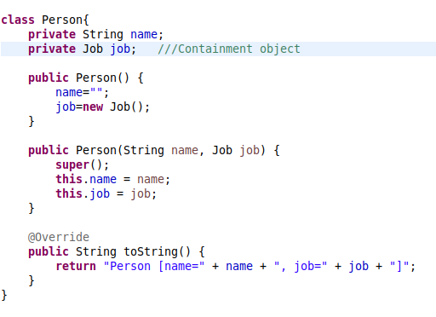

Job class

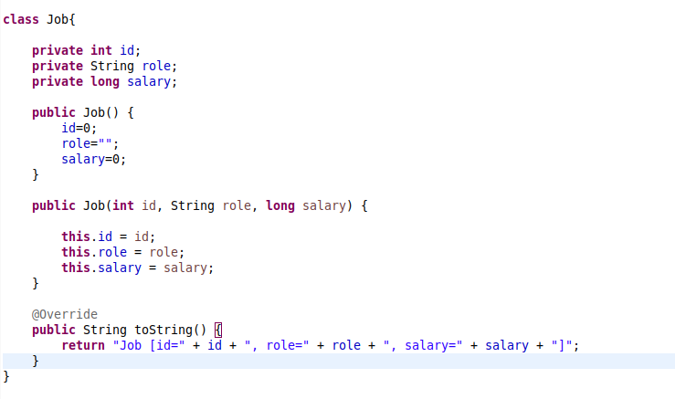

Driver code

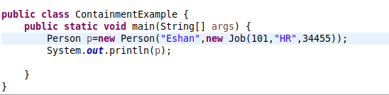

Output:

Person [name=Eshan, job=Job [id=101, role=HR, salary=34455]]

**Inner class**

A class which is declared inside the class or interface. Inner classes are used to logically group classes and interfaces in one place so that it can be more readable and maintainable.

**Syntax**

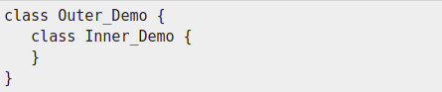

**Diagram**

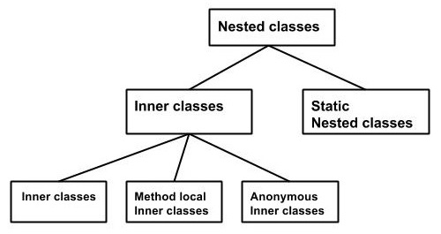

**Example**

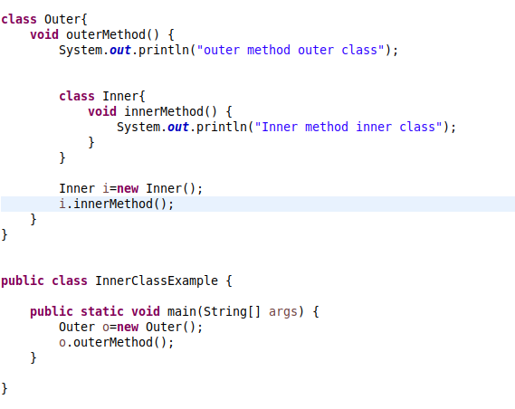

**Output:**

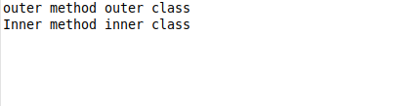

**Anonymous Inner Class**

A class that has no name is known as anonymous inner class.

**Example Code**:

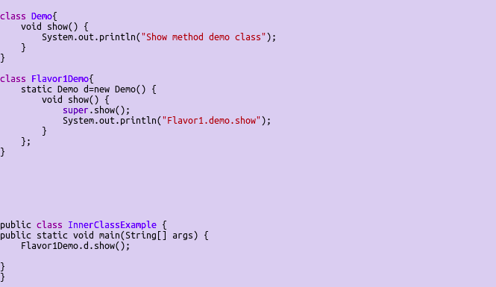

**Static Keyword**

Static keyword usage

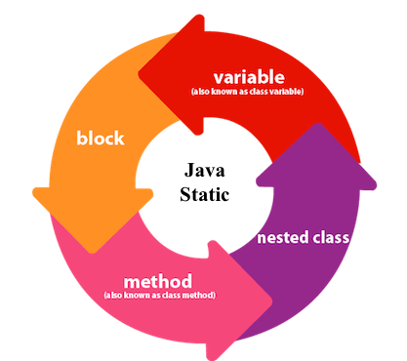

**Example code**

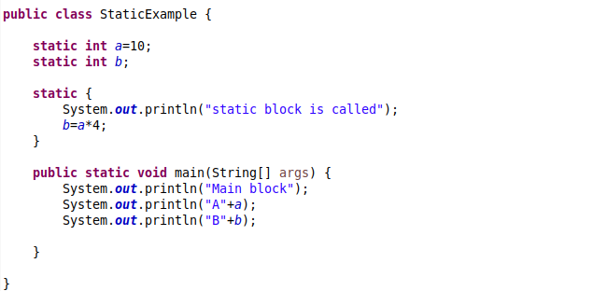

**Output**

